TNC Permits Data Exploration
  - Colorado
Elizabeth Buhr
2025-10-13
Table of Contents
1. Data Head 1
2. Common Variables 2
ENTITY_REQUESTING 2
BURNTYPE_CLASSIFIED 3
YEAR 4
ACRES_COMPLETED 5
3. Unique Variables 6
DATE (Summarized) 6
PILE_VOLUME 6
RECORD_TYPE 7
Appendix 7

1. Data Head
## RX_ID SOURCE_ID STATE YEAR DATE BURN_NAME
## 1 1 <NA> CA 2020 2020-01-22 DRD
## 2 2 <NA> CA 2020 2020-01-07 DRD
## 3 3 <NA> CA 2021 2021-01-07 DRD
## 4 4 <NA> CA 2020 2020-01-08 2019-Carveacre
## 5 5 <NA> CA 2021 2021-01-08 SUID 56
## 6 6 <NA> CA 2021 2021-11-01 Bear Basin Road Area 1(h)
## BURNTYPE_REPORTED BURNTYPE_CLASSIFIED ACRES_PERMITTED ACRES_REQUESTED
## 1 Hand Pile Pile 0 40
## 2 Hand Pile Pile 0 40
## 3 Hand Pile Pile 0 3
## 4 UNK Unknown 0 20
## 5 Broadcast Broadcast 0 10
## 6 Landing Pile Pile 0 5
## ACRES_COMPLETED PILE_VOLUME TONS ENTITY_REQUESTING NOBURNREASON_REPORTED
## 1 40 0 0 US Forest Service <NA>
## 2 15 0 0 US Forest Service <NA>
## 3 2 0 0 US Forest Service <NA>
## 4 20 0 0 US Forest Service <NA>
## 5 4 0 0 US Forest Service <NA>
## 6 5 0 0 US Forest Service <NA>
## NOBURNREASON_CLASSIFIED IN_STATE LON_ADJUSTED LAT_ADJUSTED LON_PERMIT
## 1 <NA> FALSE -116.00 32.000 -116.00
## 2 <NA> FALSE -116.00 32.000 -116.00
## 3 <NA> FALSE -116.00 32.000 -116.00
## 4 <NA> FALSE -116.42 32.450 -116.42
## 5 <NA> FALSE -116.00 32.000 -116.00
## 6 <NA> FALSE -123.84 14.813 -123.84
## LAT_PERMIT RECORD_TYPE geometry
## 1 32.000 planned_accomplished c(-1866995.89371405, 1188967.12481174)
## 2 32.000 planned_accomplished c(-1866995.89371405, 1188967.12481174)
## 3 32.000 planned_accomplished c(-1866995.89371405, 1188967.12481174)
## 4 32.450 planned_accomplished c(-1894909.1295238, 1246307.98405057)
## 5 32.000 planned_accomplished c(-1866995.89371405, 1188967.12481174)
## 6 14.813 planned_accomplished c(-3119799.25100242, -414244.135297648)
## ha_permit ha_request ha_complete burned
## 1 0 16.19 16.19 1
## 2 0 16.19 6.07 1
## 3 0 1.21 0.81 1
## 4 0 8.09 8.09 1
## 5 0 4.05 1.62 1
## 6 0 2.02 2.02 1
To compare to the Colorado Forest Tracker database and due to my research interests, I am filtering to Colorado only.

2. Common Variables
In this section I will visualize columns that are comparable to the Forest Tracker database.

ENTITY_REQUESTING
There are many unique entities, so first I created groups.
Field offices were added to the BLM group, though if this variable is used further then they should be individually evaluated.
District offices without clear identifiers are added to “other”. This is because I think the Southwest District Office (which accounts for ~100 points) is the Colorado State Forest Service, but it could also be the BLM or someone else.
Some items described as areas (ex. “Gunnison Area”, “Monte Vista Area”) are, I believe, Colorado Parks & Wildlife, because some other entries from them are formatted like “Glenwood Springs Area, Colo Pks Wildlife”. However these have been left in “other” for now.
“Local Government Agency” was included in City or Town.
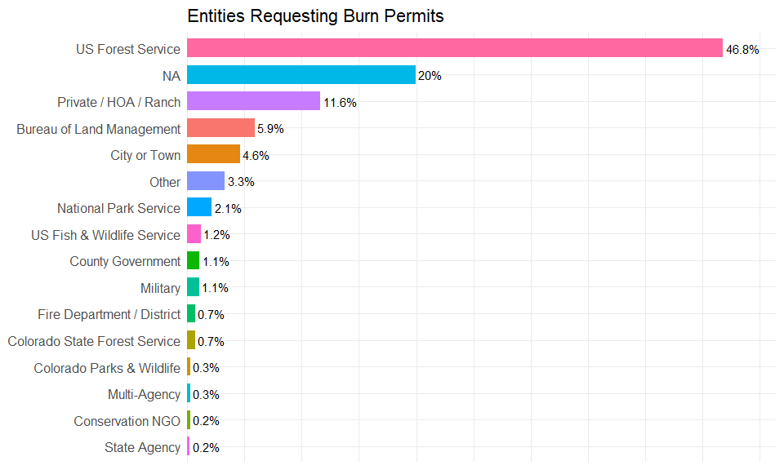

BURNTYPE_CLASSIFIED
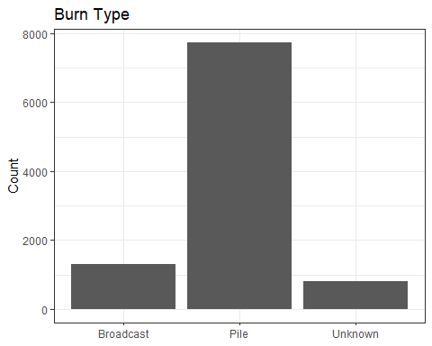

YEAR
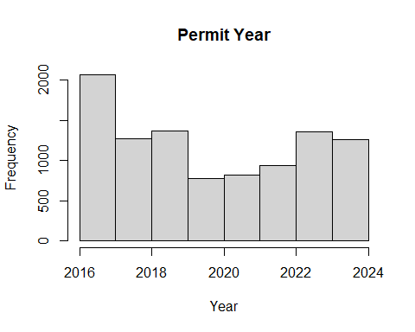
Years Range:
## [1] 2016 2024

ACRES_COMPLETED
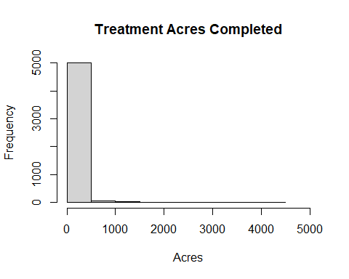
Mean Acres:
## [1] 35.1611

3. Unique Variables

DATE (Summarized)
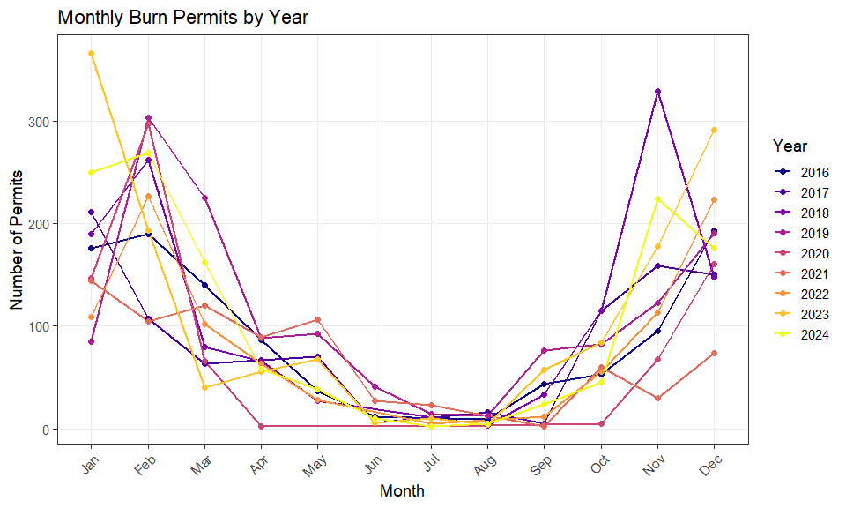

PILE_VOLUME
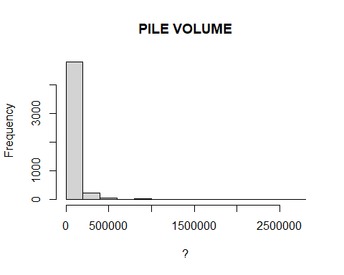
Mean:
## [1] 47485.12

RECORD_TYPE
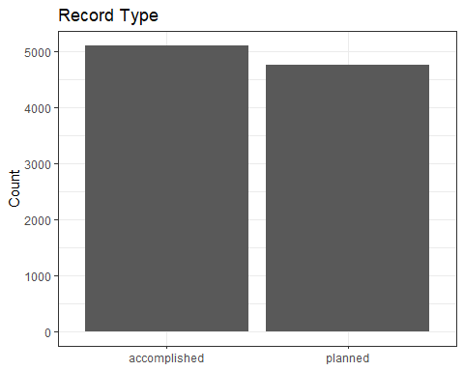

Appendix
library(knitr)
knitr::opts_chunk$set(echo = FALSE)
knitr::opts_chunk$set(message = FALSE)
knitr::opts_chunk$set(root.dir = 'C:/Users/Elizabeth Buhr/Documents/fuels-analysis/')
#load packages
library(tidyverse)
library(ggplot2)
library(scales) #graphical scales in ggplot (entity plot)
#path to file (accessed 10/7/25)
permits <- read.csv("data/rx_permit_db_share/analysis_16Sept2025.csv")
# 174122 observations
#check column names and values
head(permits)
permits <- filter(permits, STATE == "CO")
#9863 observations for burns - about twice as much as forest tracker
df_entity <- permits %>%
mutate(
ENTITY_GROUP = case_when(
# Forest Service
str_detect(ENTITY_REQUESTING, regex("National Forest|Natl Forest|Nat'l Forest|Forest Service", ignore_case = TRUE)) ~ "US Forest Service",
# Colorado State Forest Service
str_detect(ENTITY_REQUESTING, regex("Colo State Forest Svc|Colorado State Forest Svc|CSFS|Coo State Forest Svc", ignore_case = TRUE)) ~ "Colorado State Forest Service",
# BLM
str_detect(ENTITY_REQUESTING, regex("BLM|Bureau of Land Management|Field Office|Field Offfice|Field Office", ignore_case = TRUE)) ~ "Bureau of Land Management",
# National Park Service
str_detect(ENTITY_REQUESTING, regex("National Park|National Monument|National Recreation Area", ignore_case = TRUE)) ~ "National Park Service",
# National Wildlife Refuge / USFWS
str_detect(ENTITY_REQUESTING, regex("Wildlife Refuge|Fish and Wildlife|USFWS", ignore_case = TRUE)) ~ "US Fish & Wildlife Service",
# Colorado Parks & Wildlife
str_detect(ENTITY_REQUESTING, regex("Colo Parks|Colorado Parks|CPW|Colo Pks Wildlife", ignore_case = TRUE)) ~ "Colorado Parks & Wildlife",
# State Agencies (non-CSFS)
str_detect(ENTITY_REQUESTING, regex("State Land Board|Colorado State Parks|State Land", ignore_case = TRUE)) ~ "State Agency",
# County Governments
str_detect(ENTITY_REQUESTING, regex("County", ignore_case = TRUE)) ~ "County Government",
# Cities and Towns
str_detect(ENTITY_REQUESTING, regex("City of|Town of|Metro|Metropolitan|Utilities|Local Government Agency", ignore_case = TRUE)) ~ "City or Town",
# Fire Departments / Districts
str_detect(ENTITY_REQUESTING, regex("Fire|F.D.|Fire Dept|Fire Protection|Fire District", ignore_case = TRUE)) ~ "Fire Department / District",
# Private / HOA / Ranch
str_detect(ENTITY_REQUESTING, regex("Ranch|Private|HOA|Association|Metro District|Resort|Assn", ignore_case = TRUE)) ~ "Private / HOA / Ranch",
# Military
str_detect(ENTITY_REQUESTING, regex("Army|Military|Air Force|SFS", ignore_case = TRUE)) ~ "Military",
# Conservation NGOs
str_detect(ENTITY_REQUESTING, regex("Conservancy|Trust|Foundation", ignore_case = TRUE)) ~ "Conservation NGO",
# Multi-Agency / Other labels
str_detect(ENTITY_REQUESTING, regex("Multiple", ignore_case = TRUE)) ~ "Multi-Agency",
# NA or blank
is.na(ENTITY_REQUESTING) | ENTITY_REQUESTING == "" ~ "NA",
# Catch-all
TRUE ~ "Other"
)
)
# df_entity %>%
# filter(ENTITY_GROUP == "Other") %>%
# count(ENTITY_REQUESTING, sort = TRUE)
# Summarize by ENTITY_REQUESTING
df_grouped <- df_entity %>%
group_by(ENTITY_GROUP) %>%
summarise(Count = n()) %>%
mutate(
Percent = Count / sum(Count),
PercentRounded = round(100 * Percent, 1),
Label = paste0(PercentRounded, "%")
) %>%
filter(PercentRounded > 0) %>% # Remove entities with 0.0%
arrange(Percent) # Smallest to largest
# Plot
ggplot(df_grouped, aes(x = reorder(ENTITY_GROUP, Percent), y = Percent, fill = ENTITY_GROUP)) +
geom_bar(stat = "identity", width = 0.7, show.legend = FALSE) +
geom_text(aes(label = Label), hjust = -0.1, size = 4) +
scale_y_continuous(labels = percent_format(), expand = expansion(mult = c(0, 0.1))) +
labs(
title = "Entities Requesting Burn Permits",
x = NULL,
y = NULL
) +
coord_flip() +
theme_minimal(base_size = 14) +
theme(
axis.text.x = element_blank(),
axis.ticks.x = element_blank(),
axis.text.y = element_text(size = 12)
)
#BURNTYPE_CLASSIFIED Bar Plot
ggplot(permits, aes(x = BURNTYPE_CLASSIFIED)) +
geom_bar() +
theme_bw() +
labs(title = "Burn Type", x = NULL, y = "Count")
# YEAR_COMP histogram
hist(permits$YEAR, main = "Permit Year", xlab = "Year", xlim = c(2016,2024), breaks = 8)
range(permits$YEAR)
#histogram of ACRES_MGT
hist(permits$ACRES_COMPLETED, main = "Treatment Acres Completed", xlab = "Acres", xlim = c(0, 5000))
#Mean
mean(permits$ACRES_COMPLETED, na.rm = TRUE)
#Mean = 35.1611
# Create Date Summaries using package lubridate
# Convert character to Date
permits$DATE <- ymd(permits$DATE)
# Extract features
permits$year <- year(permits$DATE)
permits$month <- month(permits$DATE, label = TRUE)
permits$day <- day(permits$DATE)
# Group by year-month
permits_summary <- permits %>%
filter(!is.na(year), !is.na(month)) %>% # drop NAs
group_by(year, month) %>%
summarise(n = n(), .groups = "keep")
#Dates Time Series (x = month, y = count, group = year)
ggplot(permits_summary, aes(x = month, y = n, group = year, color = factor(year))) +
geom_line(linewidth = 1) +
geom_point(size = 2) +
labs(
title = "Monthly Burn Permits by Year",
x = "Month",
y = "Number of Permits",
color = "Year"
) +
theme_bw(base_size = 14) +
theme(
panel.grid.minor = element_blank(),
axis.text.x = element_text(angle = 45, hjust = 1)
) +
scale_color_viridis_d(option = "C")
#PILE_VOLUME
hist(permits$PILE_VOLUME, main = "PILE VOLUME", xlab = "?")
mean(permits$PILE_VOLUME, na.rm = TRUE)
# RECORD_TYPE
ggplot(permits, aes(x = RECORD_TYPE)) +
geom_bar() +
theme_bw() +
labs(title = "Record Type", x = NULL, y = "Count")

